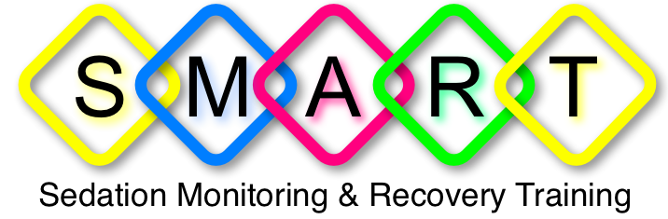

Lecture notes
Inhalation Sedation machine

Aim
Go through the components of an IH machine and the checks required to ensure it is ready for use.

Learning outcomes:-
By the end you should know :-
- The components of the IH machine
- The safety components of the IH machine
- What safety checks is required to ensure IH machine ready for use
- The essential equipment required regarding an IH session

ESSENTIAL FEATURES OF INHALATION SEDATION MACHINE
Must :-
- Have a Fail safe device
- Be impossible to deliver 100 % N₂O
- Have a minimum O₂ flow device
- Have a maximum N₂O flow
- Have adequate emergency Oxygen flow from an accessible flush button
- Have effective scavenging equipment

HIGHLY DESIRABLE FEATURES OF IHS MACHINE
- Adequate servicing arrangements
- Flow meter that is angled
- Flow meter marked in regular steps through the range
- Control valves which are smooth and positive in action
- Control valves space sufficiently far apart to avoid unintentional alteration
- One way valve machine outlet to avoid the possibility of re-breathing.
- An air entrainment valve to prevent asphysia sensation if gas fails or the flow is inadequate.

DESIRABLE & OPTIMAL FEATURES OF IHS MACHINE
- Economy in use
- Varity of mountings to suit individual needs and be inconspicuous
- to the patient
- In case of O₂ failure N₂O should fall in proportion set as the oxygen flow falls
- Provision for attachment of resuscitator to Oxygen supply.
- Clean uncluttered appearance
- Nasal inhalers and tubing available in pastel shades

COMPONENTS OF RA MACHINE
- Compressed gas cylinders
- Two reducing valves - factory set at 50-55 psi
- Pressure gauges
- Flow meters – expressed in liter per min.
- Mixture control
- Reservoir bag
- Tubing – blue N₂O and white O₂
- nasal mask

SAFETY FEATURES OF RA MACHINE
- Pin indexing and colour coding of cylinders
- Colour coding of tubing and different fixings
- N₂O cut off if o₂ fails
- Minimum delivery of 30% oxygen
- Air entrainment valve
- Emergency oxygen flush
- Scavenging

IHS MACHINE
- Regularly serviced & calibrated to manufacturers recommendations
- Kept in secure place
- Keep key separately
- Check machine function at start of each day

DAILY IHS MACHINE CHECK
Aims
- To check contents of all cylinders
- To check correct functioning of controls and flowmeter
- To check automatic cut-out of N2O flow
- To check the reservoir bag for leaks

SCAVENGING
There should be adequate scavenging of waste gases where inhalation sedation is used since inadequate scavenging many result in unacceptable risks to health of the dental team. It should conform to current COSSH.

Conclusion
Please ensure that:-
- You are using an Inhalation Machine that have been services regularly and that fulfil all the essential criteria’s
- The inhalation machine have all the recommended desirable and highly desirable features
- You do carry out the safety checks prior to it’s use.

